

**Airline Satisfaction: Transforming a Dataset and CrossTabs**

*\*\*\*Note: ensure you watch the LinkedIn Learning Videos for Week 1 before working on this assignment*

Customer satisfaction is an important metric for many organizations. Research has shown that satisfied customers are more likely to be loyal customers and have higher repeat purchases than unsatisfied customers. Airlines for many years have tracked customer satisfaction. With multiple airlines to choose from, it is easy for customers to defect to other airlines. Along with price and flight duration, satisfaction with an airline is one of the factors customers use to select an airline when travelling.

A major airline commissioned a marketing research firm to conduct satisfaction research of travelers over a three-month period. The research company supplied the dataset **airline satisfaction.sav**. As is the norm, the dataset needs to be “cleaned up” and put in a useable form. Very often researchers will need to recode data to format it in a form to address a specific research question or recode string variables, variables entered as text, into numeric variables that can be used in calculations.

After cleaning up the dataset and recoding the necessary variables, it is wise for a researcher to “get to know” the dataset. This allows a researcher to understand which variables are related, and for nominal and ordinal variables, what are their distributions, or frequency, of each of the groups. For example, how many men and women are in the dataset? Knowing this information gives a researcher some insight on where to start the analysis and where to look for certain information. Another useful function in SPSS to “get to know” your dataset is Explore, including histograms, and is a quick and easy way to get a feel for the structure of the data.

CrossTabs is a simple but powerful technique for determining relationships between variables. CrossTabs is a procedure that cross-tabulates two variables, thus displaying their relationship in tabular form. In contrast to Frequencies, which summarizes information about one variable, CrossTabs generates information about *bivariate* relationships. Combined with a chi-square test, significance of the relationship between variables can be determined and pattern of the relationship. Using the layer feature in SPSS, a two-way table for each category of the layer variable can be produced that determines the relationship between multiple variables. Sub-tables are produced for each combination of categories for each first-layer variable, each second-layer variable, and so on. Applying a chi-square test of significance, analysts can determine the significance for different sub-groups of the layer variable(s).

CrossTabs is widely used in quantitative market research and surveys. It helps identify the type of response by a particular category of respondents. This helps in understanding what effects an action will have on a category of the target market. For example, a survey might be used to gauge the effectiveness of a particular campaign on its male versus female customers.

CrossTabs can be used with nominal, ordinal, or interval data, and it has a number of advantages over other statistical techniques. First, CrossTabs are easy to understand. Second, CrossTabs provides comparative data on two or more variables across multiple features at one glance.

Having received this dataset, you notice that there are a number of string variables. You will need to “clean up” the dataset by converting the string variables into numeric equivalents so they can be used in future analysis. Additionally, you need to “get to know” your dataset. A combination of correlation and frequency analysis will give a nice overview of the data. After cleaning and getting to know your dataset, you will conduct CrossTabs analysis to understand some of the relationships in the dataset.

***Part I: Transform String Variables to Numeric Variables***

For the string variables listed in the table below, transform the variables to numeric variables using the levels as outlined in the table for each variable. **Then, take a screenshot of either the new variables on the Variable View or on the Data View.**

|  |  |  |  |  |  |
| --- | --- | --- | --- | --- | --- |
|  | **Airline Status** | **Age Range** | **Class** | **Flight cancelled** | **Arrival Delay greater 5 Mins** |
| **0** |  |  |  | No | No |
| **1** | Blue | 0-19 | Business | Yes | Yes |
| **2** | Silver | 20-29 | Eco |  |  |
| **3** | Gold | 30-39 | Eco Plus |  |  |
| **4** | Platinum | 40-49 |  |  |  |
| **5** |  | 50-59 |  |  |  |
| **6** |  | 60-69 |  |  |  |
| **7** |  | 70-79 |  |  |  |
| **8** |  | 80+ |  |  |  |
| **9** |  |  |  |  |  |
| **10** |  |  |  |  |  |

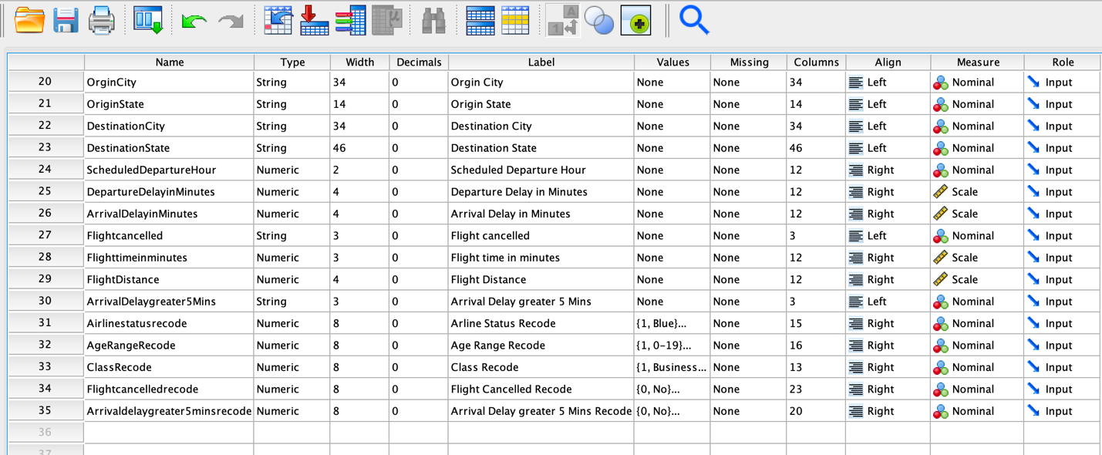   
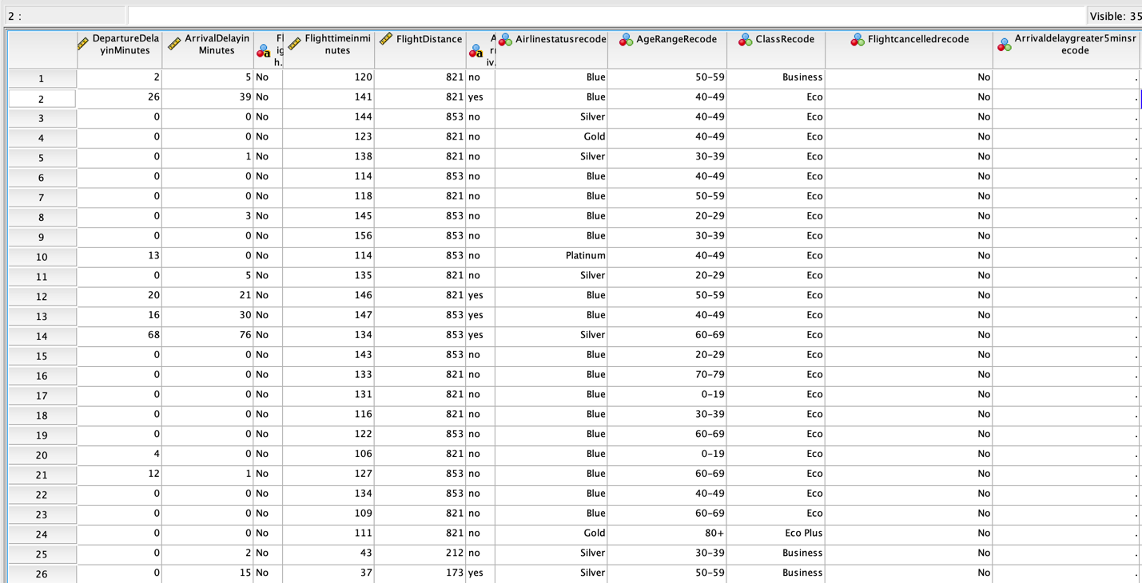

I noticed that when I changed the Arrival delay greater than 5 mins it was already in No and Yes. So, it came out looking like (.) instead.

***Part II: Correlations***

1. Generate a correlation table for the scale variables using Correlate > Bivariate for the variables.

Satisfaction

Age

NoofFlightsp.a

ShoppingAmountatAirport

ArrivalDelayinMinutes

Flighttimeinminutes  


2. For this list of variables:

NoofFlightsp.a

ShoppingAmountatAirport

ScheduledDepartureHour

Flighttimeinminutes



1. Use the Explore function to review the variables, including producing a “histogram” for each variable. Paste the histograms for each variable here in your homework. You do not need to include the Explore table.

Satisfaction  


Age  


No. of flights p.a.

Shopping Amount at Airport

Arrival Delay in Minutes

Scheduled Departure Hour  
 

b) Do you find any of the histograms interesting? Why?   
In the shopping amount at airport there are more people who do not spend at the airport. I would think they spend more on food at least. There also seems to be no delay in minutes at the airport which is really good. This would mean they are typically on time.

***Part III: CrossTabs***

1. Generate the following CrossTab analysis with Chi-Square significance tests.

|  |  |  |
| --- | --- | --- |
| Rows | Columns | Layer |
| NoofFlightsp.a.grouped | Gender |  |
| Satisfaction | Type of Travel |  |
| Satisfaction | AgeRange | Gender |

2. **For each cross-tabs,** paste the results and then answer the questions: What do the CrossTabs results tell you? In addition, as a marketing manager, how could you use this analysis and initial data gathering to inform decisions moving forward and/or additional research you would suggest for future/further insights?

Step 1: H0: No. of flights grouped and gender are independent  
 H1: No. of flights grouped and gender are not independent

Step 2: Determine statistical test and significance

Step 3: p-value > .05; Then do not reject H0 p-value < .05; Then reject H0

Step 4: Calculate cross tabs and chi-square test

Step 5: Apply decision rule and draw conclusion  
.001 < .05; Then reject H0They’re not independent so they’re related somehow.   
Conclusion: Females from 0-30 take more flights than men, but at a certain point men 31-100 start traveling more than women. This may be due to men working more to support their families and women are traveling less to have children. We can use this analysis to promote campaigns to encourage women with children to travel by offering a family package or offer nursery at the airport. We can make better marketing decisions by conducting surveys directed towards women between the ages of 31-70 to see how we can improve their experience at the airport.





Step 1: H0: Satisfaction and Type of travel are independent  
 H1: Satisfaction and Type of travel are not independent

Step 2: Determine statistical test and significance

Step 3: p-value > .05; Then do not reject H0 p-value < .05; Then reject H0

Step 4: Calculate cross tabs and chi-square test

Step 5: Apply decision rule and draw conclusion  
.000 < .05; Then reject H0They’re not independent so they’re related somehow.   
Conclusion: Business travelers are more satisfied followed by mileage ticket, and personal travel are least satisfied. We can use the data analysis to create a new goal to improve the satisfaction of the personal travelers. We can offer drink vouchers or better snack vouchers if they have a cancelled flight or send out an email campaign that will help them earn points on their credit card.

Step 1: H0: Age, gender, and satisfaction are independent  
 H1: Age, gender, and satisfaction are not independent

Step 2: Determine statistical test and significance

Step 3: p-value > .05; Then do not reject H0 p-value < .05; Then reject H0

Step 4: Calculate cross tabs and chi-square test

Step 5: Apply decision rule and draw conclusion  
Male: .000 > .05; Then reject H0Female: .000 > .05; Then reject H0They’re not independent so they’re related somehow.   
Conclusion: Because male and female p-value is less than .05 we know there is a relationship between age, gender, and satisfaction and that there is a significant pattern. We know that the satisfaction between men and women and age group are exactly the same. Ages between 30-59 are most satisfied. We see that the male has a stronger relationship from the female by looking at the Pearson Chi-Square. Ages between 30-59 are most satisfied. We can use this information to build campaigns to target males between 20-59 to improve their satisfaction by earning points on their credit card or towards their miles.

***Part IV: Report***

Please submit the homework as an updated SPSS file (.sav) + a WORD document of your results and answers. Please simply paste in your answers and the requested output for Parts II and III respectively in this document. So, only one document + 1 [.sav] file will be submitted.